 | Banco Santander Internacional  1401 Brickell Avenue, Suite 1500 - Miami FL 33131

Project Implementation Plan
Release ID | RLSE1370716
IT Manager | Jose Luis Martinez Avial
Business Manager | Ted Fernandez
Requested by | Marcus Medeiros Carneiro
Tested by | Marcus Medeiros Carneiro
Assigned to | Ahamed Shanavaz
Summary | Security Lending Phase 2

Special tasks

Pre-implementation tasks | N/A
During Implementation tasks | Verify that the below subroutine is compiled successfully  JPM.BP>SPB.JPM.RISK.CONTROL  SECLEND.BP>CREATE.SL.PAYMENT.ENTRIES  SECLEND.BP>LOAD.SEC.LEND.CUST.POS  SECLEND.BP>V.SL.PAY.GET.ACCT.BAL  MEDEA.BP>M011D  ENQ.BP>E.NOFILE.SEC.LEND.RISK.LIMIT
Post-implementation tasks | N/A

Description/Functional Requirements

- The business wants to increase the size of the loans to some counterparties to allow USD 5OOMM for 9 strategic borrowers. Since the business can decide to increase/decrease the size of loans again in the future, ideally the solution should allow us to have a “table” in T24 that would allow to define the limits per counterparty as a parameter that we can easily change in the future.
- If there are differences between the payment received from JP Morgan and daily accruals accumulated In T24, the accruals must be recalculated to match the payment amount upon approval from BSI Treasury.
- The fiscal Report should be updated as below

- New section must be created for “Securities Lending”
- The “Securities Lending” section should be placed before the “Fees” section
- The “Securities Lending” section should have a table with the following columns:
  - Payment Date
  - Payment Type: “Fee Income" by default
  - Description: "Security Lending Income - Month name" by default
  - Currency: “USD”
  - Amount

Justification/Requirements Analysis

- The limit for different borrowers is parameterized in the table SC.SPB.SEC.LENDING.PARAM and the routine SPB.JPM.RISK.CONTROL is changed to validate if there are any limits per borrower.
- The routine CREATE.SL.PAYMENT.ENTRIES is changed to recalculate the accruals and payment to clients whenever there is a difference between the payment received and the accrual amount.
- The CREATE.SL.PAYMENT.ENTRIES is changed to modify the report as requested.

Implementation

BUILD.CONROL BDER001-RLSE1370716.SEC.LEND

- Migration details performed by Build Control BDER001-RLSE1370716.SEC.LEND

Build control migrates the following routines from test environment to production.

JPM.BP>SPB.JPM.RISK.CONTROL
SECLEND.BP>CREATE.SL.PAYMENT.ENTRIES
SECLEND.BP>LOAD.SEC.LEND.CUST.POS
SECLEND.BP>V.SL.PAY.GET.ACCT.BAL
ENQ.BP>E.NOFILE.SEC.LEND.RISK.LIMIT
INCLUDE.BP>I_F.SPB.SEC.LEND.PAYMENT
MEDEA.BP>M011D

Build control contains DL.DEFINE that migrates the following records from test environment to production.

EB.TABLE.DEFINITION>SPB.SEC.LEND.PAYMENT
VERSION>ST.SPB.SEC.LEND.PAYMENT,INP
STANDARD.SELECTION>NOFILE.SEC.LEND.RISK.LIMIT
ENQUIRY>E.SEC.LEND.RISK.LIMIT

- Please verify the BUILD.CONTROL another time if you see the warning message in the routine.
- Please add the enquiry E.SEC.LEND.RISK.LIMIT in the following menus

RISK.MENU.CML

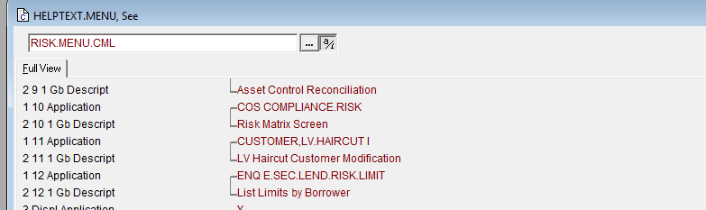

SC.SEC.LENDING

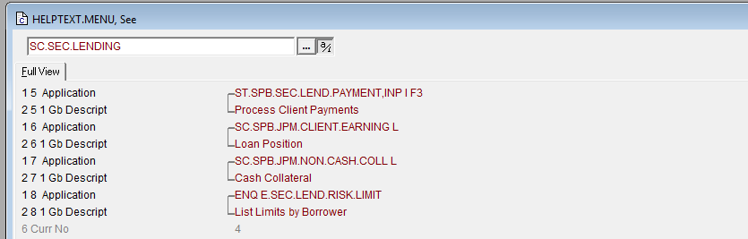

Rollback plan

COPY and COMPILE the following subroutines from backup to miaprd@miasx1

JPM.BP>SPB.JPM.RISK.CONTROL
SECLEND.BP>CREATE.SL.PAYMENT.ENTRIES
SECLEND.BP>LOAD.SEC.LEND.CUST.POS
SECLEND.BP>V.SL.PAY.GET.ACCT.BAL
ENQ.BP>E.NOFILE.SEC.LEND.RISK.LIMIT
MEDEA.BP>M011D

Routines

Existing routines:

JPM.BP>SPB.JPM.RISK.CONTROL
SECLEND.BP>CREATE.SL.PAYMENT.ENTRIES
SECLEND.BP>LOAD.SEC.LEND.CUST.POS
SECLEND.BP>V.SL.PAY.GET.ACCT.BAL
MEDEA.BP>M011D

New routines:

ENQ.BP>E.NOFILE.SEC.LEND.RISK.LIMIT

